WEB-BASED DIGITAL ARCHIVE OF COMPUTER SCIENCE PAST QUESTIONS AND LEARNING MATERIALS



BY
ENYINDAH, FAITH CHINENYE
FSC/CSC/22003976

A PROJECT SUBMITTED IN PARTIAL FULFILLMENT OF THE REQUIREMENTS FOR THE AWARD OF THE DEGREE OF BACHELOR OF SCIENCE (B.Sc.) IN COMPUTER
SCIENCE, EDO STATE UNIVERSITY, IYAMHO

FEBRUARY, 2026
TABLE OF CONTENTS
Contents
DECLARATION ii
CERTIFICATION iii
ACKNOWLEDGEMENT v
ABSTRACT vi
CHAPTER ONE 1
INTRODUCTION 1
1.0 Introduction 1
1.1.1 Background of Study 1
1.1.2 Overview of the research area (Optional) 1
1.1.3 Context of the problem (Optional) 1
1.1.4 Significance of the study 1
1.2 Statement of the Problem 1
1.2.1 Clear definition of the problem (Optional) 1
1.2.3 Research/Aim and Objectives 1
1.2.2 Specific goals of the study (Optional) 1
1.2.3 Expected outcomes (Optional) 1
1.3.4 Contribution to the field (Optional) 1
1.3 Research Questions (Optional) 1
1.4 Significance of the Study 1
1.4.1 Importance of the study 1
1.4.2 Potential impact on the field 1
1.4.3 Relevance to current issues 1
1.5 Limitations of Study 1
1.5.1 Boundaries of the study 1
1.5.2 Constraints and limitations (Optional) 1
1.5.3 Assumptions and delimitations 1
1.6 Definition of Terms 1
1.6.1 Key concepts and terminology (Optional) 2
1.6.2 Clarification of ambiguous terms (Optional) 2
1.6.3 Explanation of acronyms & abbreviations 2
1.7 Organization of the Study 2
1.7.1 Overview of the chapter (Optional) 2
1.7.2 Brief description of each chapter (Optional) 2
1.7.3 Guide for the reader (Optional) 2
CHAPTER TWO 3
LITERATURE REVIEW 3
2.1.0 Literature Review 3
2.1.1 Introduction 3
2.1.2 Overview of the chapter 3
2.1.3 Purpose of the literature review 3
2.1.4 Scope of the review 3
2.2.0 Theoretical Framework (Optional) 3
2.2.1 Underlying theories and concepts 3
2.2.2 Relevant models & frameworks (Optional) 3
2.2.3 Related Works/Review 3
2.3.0 Empirical Literature Review (Optional) 3
2.3.1 Overview of related works 3
2.3.2 Analysis of findings (Optional) 3
2.3.3 Identification of gaps and limitations 3
2.4 Conceptual Framework (Optional) 3
2.4.1 Development of a conceptual framework 3
2.4.2 Explanation of key concept & relationships 3
2.4.3 Integration of theoretical & empirical findings 3
2.5.0 Research Gaps and Limitations 3
2.5.1 Identification of gaps in existing research 3
2.5.2 Discussion of limitations and challenges 3
2.5.3 Implications for the current study 3
2.6.1 Summary of key findings 4
2.6.2 Implications for the current study 4
CHAPTER THREE 5
DESIGN AND IMPLEMENTAION 5
3.1.0 Overview of the chapter (Optional) 5
3.1.1 Purpose of the methodology chapter 5
3.1.2 Research design and approach 5
3.1.3 Methodology Used in the Proposed 5
3.2.1 Research Design (Optional) 5
3.2.3 Analysis of Existing System 5
3.2.4 Disadvantages of Existing System 5
3.2.5 Structure of Existing System 5
3.3.0 Proposed System Design 5
3.3.1 Analysis of Proposed System 6
3.3.2 Advantages of Proposed System 6
3.3.3 Structure of Proposed System 6
3.3.4 Data Collection Methods (Optional) 6
3.4.0 Data Analysis Methods 6
3.4.1 Description of data analysis techniques 6
3.4.2 Method of data coding and categorization 6
3.5.0 User Design Phase (Optional) 6
3.6.0 Use Case Model (Optional) 6
3.7.0 Sequence Diagram (Optional) 6
3.8.0 Algorithms 6
3.9.0 Logic Design (Flowchart) 6
3.1.10 Conclusion 6
3.1.11 Summary of key methodological decisions 6
3.1.12 Implications for study's validity & reliability 6
CHAPTER FOUR 7
IMPLEMENTATION AND RESULTS 7
4.1.1 Overview of the chapter (Optional) 7
4.1.2 Purpose of the results chapter 7
4.1.3 Summary of the data collection process 7
4.2.0 Implementation 7
4.2.1 Data Presentation (Optional) 7
4.2.2 Tables, figures, & graphs presenting data 7
4.2.3 Explanation of the data and its significance 7
4.2.4 Highlighting of key findings and trends 7
4.3 ,0 System Requirement/ Data Analysis 7
4.3.1 Description of data analysis methods used 7
4.3.2 Explanation of results of the data analysis 7
4.4.0 Choice of Programming Language 7
4.5.0 System Testing 7
4.6.0 Program Documentation 7
4.7.0 Findings and Discussion 7
4.7.1 Summary of the key findings 7
4.7.2 Discussion of implications of the findings 7
4.7.3 Comparison existing literature (Optional) 7
4.8.1 Summary of the key results and findings 7
4.8.2 Implications for the study's objectives and research questions (Optional) 7
CHAPTER FIVE 8
CONCLUSION AND RECOMMENDATIONS 8
5.1.0 Introduction (Optional) 8
5.1.1 Overview/Summary of chapter (Optional) 8
5.1.2 Purpose of discussion (Optional) 8
5.2.0 Conclusion Discussion of Findings 8
5.2.1 Interpretation of the results in the context of the research questions/Objective 8
5.2.2 Implications of findings for the field of study 8
5.3.1 Restatement of the research questions and objectives 8
5.3.2 Contribution to the field of study 8
5.4.1 Practical recommendations for stakeholders and practitioners 8
5.4.2 Theoretical recommendations for future research 8
5.4.3 Implications for policy and practice 8
5.5.0 Limitations and Future Research Directions 8
5.5.1 Discussion of the limitations of the study 8
5.5.2 Suggestions for future research directions 8
5.5.3 Implications for the field of study 8
5.6.0 Conclusion and Recommendations 8
5.6.1 Final summary, key findings & implications 8
5.6.2 Restatement of research questions& Obj 8
5.6.3 Closing remarks 8
REFERENCES 9
APPENDIX 10

LIST OF TABLES

Table 2. 1 Comparison of Existing System in Literature……………………………… ..................................25

Table 3. 1 Technology Used ..............................................................................................................................34
LIST OF FIGURES

Figure 3. 1 Input Design Form (Sample User Registration) .............................................................................31
Figure 3. 2 Output Design .................................................................................................................................32
Figure 3. 3: Program Flowchart ........................................................................................................................33
Figure 4. 1 Home Page ......................................................................................................................................39
Figure 4. 2 Registration and Setup ...................................................................................................................39
Figure 4. 3 Main Menu ......................................................................................................................................40
Figure 4. 4 Registration ....................................................................................................................................40
Figure 4. 5 Billings ............................................................................................................................................41

CHAPTER ONE

INTRODUCTION

1.1.1 Background of Study
The twenty-first century academy operates within a fundamentally transformed information landscape. The rapid advancement of Information and Communication Technology has shifted the core function of universities from mere creators of knowledge to complex data ecosystems requiring sophisticated digital infrastructure for knowledge preservation and dissemination. In this environment, the ability to ensure permanent accessibility of academic resources has become as critical to institutional effectiveness as the quality of instruction itself (Laudon & Laudon, 2022; Johnson et al., 2023).
Central to this ecosystem are preparatory academic resources specifically past examination questions and structured learning materials. These assets serve a dual pedagogical function: they bridge theoretical instruction with practical assessment while enabling students to engage in self-directed, temporally-flexible study. When systematically organized and reliably accessible, such resources decode examination patterns, reinforce course comprehension, and substantially reduce assessment-related anxiety (Adeyemi, 2021; Okafor & Nwankwo, 2022).
However, the mere existence of digital academic resources does not guarantee their utility. Across Nigerian higher education and at Edo State University, Iyamho specifically a persistent paradox has emerged: valuable intellectual capital is generated each academic session, yet systematically lost due to the absence of sustainable preservation infrastructure. The university operates a formal Learning Management System for current course materials, but its configuration typically restricts access to enrolled students within active semesters. Simultaneously, an extensive informal economy of resource sharing has flourished on instant messaging platforms principally WhatsApp where past questions and lecture slides circulate as chat attachments.
This parallel system, born of student resourcefulness and institutional necessity, is fundamentally misaligned with the requirements of permanent academic archiving. WhatsApp and similar platforms are designed for transient communication, not long-term document preservation. Files expire, download links fail. Chat histories are cleared as devices reach storage capacity. Students who join academic groups late experience connectivity issues during critical sharing windows, or simply lack immediate download capacity are systematically excluded from access to materials their peers possess. The institutional memory embodied in decades of examination papers and curated lecture content thus becomes fragmented across thousands of personal devices and ephemeral chat histories accessible to some, lost to others, and authoritative nowhere (Ibrahim, 2024; Nwosu, 2022; Patel & Kumar, 2023).
A further dimension of this problem, learning is one of the very vital human activities that require concentration blended with interactivity, clear and distinct understanding of the facts been stated or discussed, high communication skills and techniques, attractive learning qualities such as colourful pictorial presentations of information among others. Nevertheless, all not learning process is considered to be effective. It is impossible for 100% of the population of students lectured to assimilate the knowledge or ideas across; this is due to the high population size and existence of certain inconducive learning conditions such as, noise, poor ventilation, and extreme temperatures. With the high-quality content value of the product, a student can easily assimilate such knowledge even in the absence of the lecturer
Academic success in higher institutions depends largely on students’ access to relevant learning resources such as past examination questions and lecture slides. These materials support revision, improve understanding of course content, and help students prepare adequately for examinations and academic progression. Traditionally, academic materials were stored in printed form or kept by individual lecturers and departments, making access limited and inconsistent.
Furthermore, students preparing to advance into a new academic level often require access to lecture slides and course materials before resumption in order to study and familiarize themselves with upcoming courses. Due to the absence of a centralized academic repository, such materials are usually unavailable until lectures begin, limiting early preparation and academic readiness.

1.1.4 Significance of the study
This study is significant as it addresses the challenges associated with the informal distribution and poor management of academic resources in higher institutions. By developing a web-based digital archive of past examination questions and learning materials, the study contributes to improving accessibility, organization, and long-term preservation of educational resources.
Firstly, the study is beneficial to students. The proposed system provides continuous and centralized access to lecture slides and past examination questions, enabling students to study independently and prepare effectively for examinations. It also supports early academic preparation for students transitioning into new academic levels, allowing them to familiarize themselves with course content before resumption. This improved access can enhance student confidence, academic readiness, and overall performance.
Secondly, the study benefits lecturers and academic departments by providing a structured platform for uploading and managing learning materials. Instead of relying on informal communication platforms, lecturers can use a centralized system that ensures materials remain accessible and organized across academic sessions. This promotes better academic coordination and resource management.
The study is also significant to the institution as a whole. The implementation of a web-based digital archive strengthens institutional record-keeping practices and supports digital transformation in academic operations. It reduces the risk of material loss, improves information management efficiency, and promotes a more organized academic environment.
Furthermore, this research contributes to the body of knowledge in the fields of educational technology and information systems by providing insights into the integration of digital archiving principles with academic resource management. It may serve as a reference for future researchers who intend to develop or improve similar systems.
Overall, the study provides both practical and academic value by offering a sustainable solution to the challenges of academic material distribution and access in higher educational institutions.

1.2 Statement of the Problem
Despite the importance of past questions and lecture slides in academic preparation, many institutions lack a centralized and reliable system for managing these resources. Learning materials are frequently shared through Whatsapp platforms, where files may become inaccessible over time due to message overload, deletion, or download restrictions. As a result, students often lose access to important slides and struggle to retrieve materials when needed.
Furthermore, students advancing to a new academic level are unable to access lecture slides for upcoming courses before resumption, limiting their ability to prepare adequately. The absence of an official web-based archive for past questions and learning materials creates gaps in access, continuity, and academic readiness. This challenge necessitates the development of a web-based digital archive that ensures permanent availability, proper organization, and easy retrieval of academic resources.
Some other problems are that the students who require access to these materials need to go to the library or offices physically which most times could lead to congestion and repeated use of these learning materials can lead to degradation of the hard copy.
The implementation of a web-based digital repository for scholarly materials will help curb the problems listed above by providing an efficient and reliable solution for prompt uploading, storing and retrieval of the institution’s learning materials. Also, being web-based means that you can have several users accessing the repository and archived materials at any time.

1.3 Aim and Objectives
Aim:
The primary objective of the topic is to design and implement a web-based digital archive for effective storage, management, and retrieval of past questions and learning materials
Objectives:
- To examine the existing methods of archiving and accessing academic resources.
- To design a database structure for organizing past questions and learning materials by course, department, level, and academic session.
- To develop a robust web-based digital archiving system that enables authorized users to upload and manage academic materials and enhance revision and learning.

1.4 Significance of the Study
For students, the system provides a centralized and reliable platform for accessing past questions and learning materials at any time. This reduces the stress of searching through multiple sources and improves academic preparation, especially before examinations or at the beginning of a new semester.
For academic departments, the digital archive ensures that materials are systematically stored and preserved. It minimizes the risk of data loss and eliminates inconsistencies caused by informal file sharing. From a technological perspective, this study demonstrates the practical application of database systems, web development, and role-based access control in solving real-world academic problems. It serves as a reference model that can be adapted or extended by other institutions seeking to implement similar systems.
Overall, the study contributes to improving academic resource management, strengthening data security, and promoting a more organized and accessible learning environment.

1.5 Limitations of Study
First, the system is designed and tested within a specific institutional context. As a result, the findings and system performance may not be fully generalizable to other institutions with different technological infrastructures, policies, or user requirements.
Secondly, the implementation focuses primarily on two user roles, Administrator and Student. Other potential stakeholders, such as lecturers or departmental staff, are not fully integrated into the system at this stage. Another limitation relates to data availability. The effectiveness of the system depends on the quality and completeness of materials uploaded into the archive. If academic materials are not consistently updated or properly categorized, the system’s usefulness may be reduced.
Furthermore, the study does not extensively evaluate long-term system performance under high traffic conditions. Scalability considerations are addressed conceptually, but full stress testing may require deployment in a live institutional environment over time. Internet dependency also presents a limitation. Since the archive is web-based, access requires stable internet connectivity. Students in areas with limited or unreliable internet access may experience challenges using the system effectively.
Despite these limitations, the system provides a practical and scalable foundation for improving academic resource management within the institution

1.6 Definition of Terms
- Digital Archive: A system for storing and managing electronic documents for long-term access. Saha (2006) defines digital archiving as long-term maintenance of a byte stream with the aim of reproducing a facsimile of the original document mainly for continued accessibility of the document contents through time and changing technology.
- Learning Materials: Educational resources such as lecture slides, note and course textbooks
- Web-Based System: An application accessed through a web browser over the internet
- Past Questions: are historical examination papers and assessment records from previous academic sessions that serve as pedagogical benchmarks for students to understand examiner expectations and syllabus requirements.
- Database Management System (DBMS): A Database Management System (DBMS) is software that enables the creation, management and use of databases. In the context of digital archive of past questions and learning materials, a DBMS is used to organize and store past exam questions, making them easily retrievable through search and filter functions.
- LMS (Learning Management System):
A software application designed to manage, deliver, and track educational content. The proposed digital archive shares similarities with an LMS but focuses specifically on storing and retrieving past questions and learning materials.
- HTML (HyperText Markup Language):
A standard markup language used to create and structure web pages. It forms the basic structure of the web-based digital archive interface. • CSS – Cascading Style Sheets
- JS (JavaScript):
A high-level programming language used to create interactive and dynamic features on web pages. In a web-based digital archive system, JavaScript enables functionalities such as form validation, dynamic content updates, and user interaction without reloading the page.
- URL (Uniform Resource Locator):
The web address used to locate and access resources on the internet. Within the proposed system, URLs are used to navigate between pages and retrieve stored academic materials.
- PDF (Portable Document Format):
A widely used file format for presenting documents in a fixed layout that preserves formatting across different devices and platforms. In this study, past examination questions and lecture slides may be stored and accessed in PDF format within the digital archive.
- UI (User Interface):
The visual elements of a system through which users interact with software applications, such as buttons, menus, and forms.
- UX (User Experience):
The overall experience and satisfaction a user has while interacting with a system or application.
- SQL (Structured Query Language):
A programming language used to manage and manipulate data stored in relational databases.
- API (Application Programming Interface):
A set of rules and protocols that allows different software applications to communicate with each other. In the context of this study, APIs enable interaction between the frontend and backend components of the web-based digital archive system.

1.7 Organization of the Study
This project is organized into five chapters.
Chapter One introduces the study, outline of the background, problem statement, objectives and significance.
Chapter 2 reviews related literature.
Chapter 3 discusses system analysis and design.
Chapter 4 presents implementation and results.
Chapter 5 concludes the study and provides recommendations

CHAPTER TWO

LITERATURE REVIEW

2.1 Introduction
The growing trend towards online scholarly communication and lack of content management systems among universities has made digital repositories more important for the collection and distribution of scholarly materials. In a general sense, and “digital archive” may mean several thongs; a library, a repository, a museum, or even a warehouse that stores academic resources for use and safekeeping.
Digital archiving refers to the process of converting physical or scattered electronic documents into structured digital formats that can be stored, managed, and retrieved using computer-based systems. Studies have shown that digital archives improve information preservation and enhance accessibility by allowing users to retrieve materials quickly through search and categorization features (Smith, 2020). In academic settings, digital archives are increasingly used to store research outputs, lecture materials, and examination records, thereby supporting both teaching and learning activities.
Several studies have examined the use of digital repositories and learning management systems (LMS) in higher institutions. Research by Okafor and Nwankwo (2018) revealed that institutions that adopted centralized digital repositories experienced improved organization of academic materials and increased student satisfaction. Similarly, Adebayo (2019) reported that students who had access to online repositories of past questions demonstrated better familiarity with examination patterns and improved academic preparedness.
Despite these advantages, many institutions still rely on informal platforms such as WhatsApp for sharing lecture slides and learning materials. While such platforms offer quick communication, they are not designed for long-term storage or structured retrieval of academic content. Studies have shown that materials shared through instant messaging systems are often lost due to message overload, file expiration, or deletion, making it difficult for students to retrieve them when needed (Ibrahim & Musa, 2020). This challenge becomes more significant for students who are unable to download materials immediately or who join academic groups late.
Furthermore, research highlights the need for systems that integrate multiple types of academic resources into a single platform. Studies by Williams (2021) emphasize that combining past examination questions with learning materials in one digital archive enhances usability and supports comprehensive learning. Such systems allow students to relate lecture content with examination requirements, improving understanding and academic performance.
In summary, existing literature demonstrates that web-based digital archives play a crucial role in improving the accessibility, organization, and preservation of academic resources. While digital repositories and learning management systems have been implemented in some institutions, gaps remain in the availability of centralized platforms that specifically integrate past questions and learning materials for continuous student access. This study seeks to address these gaps by developing a web-based digital archive that supports effective academic preparation and long-term resource management.
This chapter presents a detailed review of literature related to web-based digital archives, past examination questions, and learning materials in educational institutions. It examines relevant concepts, theories, and previous studies that focus on digital archiving, web-based information systems, and academic resource management. The chapter also highlights existing challenges in the distribution and accessibility of academic materials and identifies gaps that justify the need for the proposed system.

2.1.3 Purpose of the literature review
The purpose of this literature review is to examine existing scholarly works related to digital archiving and web-based academic resource systems. It aims to understand current approaches to storing and distributing learning materials, identify limitations in existing systems, and establish a theoretical and empirical foundation for the present study. The review also helps to justify the development of a web-based digital archive of past questions and learning materials.

2.1.4 Scope of the review
The scope of this literature review covers studies related to digital archiving, web-based information systems, academic repositories, and the management of learning resources in higher educational institutions. Emphasis is placed on literature that addresses accessibility, storage, retrieval, and preservation of academic materials such as lecture slides and past examination questions. The review is limited to concepts and studies relevant to the objectives of the current research.

2.2.0 Theoretical Framework
The theoretical framework provides the conceptual foundation upon which the study is built. It explains the theories and models that guide the design, development, and implementation of the proposed web-based digital archive of past questions and learning materials. In educational technology research, theoretical frameworks help to justify why a particular system is necessary and how it supports effective teaching and learning processes.
Another relevant framework is the Information Systems Theory, particularly the concept of information management systems. Laudon and Laudon (2018) describe information systems as structured systems designed to collect, store, process, and distribute information to support decision-making and organizational activities. In an academic environment, a digital archive functions as an information system that manages educational resources in a centralized and organized manner. Applying this theory justifies the need for a structured web-based system rather than informal file sharing platforms.
Essentially, this study is guided by constructivist learning theory, self-directed learning theory, information systems theory, the Technology Acceptance Model, and digital repository concepts. These frameworks collectively justify the development of a web-based digital archive as a tool for improving access to academic resources, enhancing student preparedness, and supporting effective learning practices.

2.2.1 Underlying theories and concepts
One of the major theories relevant to this study is the Constructivist Learning Theory. Constructivist theory emphasizes that learners actively construct knowledge through interaction with learning materials rather than passively receiving information. According to Piaget (1972), learning occurs when individuals engage with content, explore ideas, and relate new information to prior knowledge. Access to past questions and lecture slides through a digital archive allows students to independently interact with learning materials, revise concepts repeatedly, and build deeper understanding at their own pace.
Closely related to constructivism is the concept of self-directed learning. Self-directed learning theory suggests that learners take responsibility for identifying their learning needs, selecting appropriate resources, and evaluating their progress. A web-based digital archive supports self-directed learning by allowing students to retrieve past questions and slides anytime without depending solely on lecturers or classmates.

2.2.2 Related Works/Review
The reviewed works reveal that significant efforts have been made in the development of digital systems for managing academic resources in educational institutions. Previous studies and systems have demonstrated that web-based platforms improve accessibility, organization, and retrieval of learning materials such as lecture slides and past examination questions. These systems support independent learning, enhance student preparedness, and reduce reliance on traditional paper-based or informal electronic methods.
The Blended Learning Framework supports the integration of digital resources into traditional learning environments. Blended learning combines face-to-face teaching with online learning tools to enhance educational outcomes. Graham (2013) noted that digital learning resources complement classroom instruction by providing students with additional study materials outside lecture hours. A web-based archive of slides and past questions strengthens blended learning by extending learning beyond the physical classroom
Mohammed and Zhang (2024) explored institutional digital repositories in African universities, noting that while 65% of surveyed institutions had some form of digital archive, only 28% specifically catered to student-facing resources like past questions. Their study emphasized the gap between research-focused repositories and student learning needs.
Similarly, Okafor et al. (2023) implemented a mobile-based archive at the University of Lagos, reporting 89% student satisfaction but noting limitations in search functionality and file categorization.
Adeyemi (2020) conducted a study on the development of a web-based academic repository for storing and accessing lecture materials in a higher institution. The study revealed that students who had access to a centralized digital platform were able to retrieve learning materials more easily compared to those who relied on informal sharing methods. The system improved accessibility and reduced dependence on physical documents. However, the study focused mainly on lecture notes and did not integrate past examination questions into the repository.
Recent studies by Thompson (2024) and Williams et al. (2023) demonstrate evolving LMS capabilities, with Canvas and Moodle 4.0 incorporating better archival features. However, Chen's (2024) comparative analysis of 15 universities found that even advanced LMS platforms typically restrict past question access to current students only, creating what she termed "academic amnesia" across cohorts.
Okafor and Nwankwo (2019) examined the use of online repositories for managing past examination questions in tertiary institutions. Their findings showed that access to past questions helped students understand examination patterns and improved their level of preparedness. Despite these benefits, the study identified challenges related to limited system functionality and lack of integration with other learning materials such as lecture slides.
A study by Ibrahim and Musa (2020) investigated the use of instant messaging platforms for sharing academic materials among university students. The research found that although platforms such as WhatsApp were widely used due to their convenience, they were unsuitable for long-term academic resource management. Files were often lost due to message overload, expiration, or accidental deletion. The study recommended the adoption of structured web-based systems to improve storage and retrieval of learning materials.
Adebayo (2019) developed an e-learning support system that provided students with access to digital learning resources. The results indicated improved student engagement and independent learning. However, the system primarily focused on instructional content delivery and did not adequately address long-term archiving or preservation of academic materials across academic sessions.
The OER movement, documented in recent reviews by UNESCO (2024) and the Open Education Consortium (2023), provides valuable models for resource sharing. However, regional analyses by African scholars (Mbeki, 2023; Nkrumah, 2022) note that OER platforms often lack localized, curriculum-specific content for Nigerian higher education contexts.
Brown and Clarke (2019) studied the impact of early access to learning materials on student performance. The findings revealed that students who accessed course materials before the commencement of the academic session adjusted more easily to coursework and performed better academically. The study, however, did not propose a specific system for ensuring continuous access to such materials, especially for students transitioning into new academic levels.
Johnson et al. (2021) evaluated a web-based learning management system used in a university environment. The study highlighted the benefits of centralized storage, user authentication, and controlled access to academic resources. Despite its effectiveness, the system was designed mainly for course delivery and assessment, with limited emphasis on archiving past questions for long-term academic reference.

2.3.2 Identification of gaps and limitations
The review and analysis of related literature reveal several gaps and limitations in existing systems and studies on digital archiving and web-based academic resource management. Although many researchers acknowledge the benefits of digital repositories and online learning platforms, current solutions do not fully address the academic needs of students in a comprehensive manner.
One major gap identified is the lack of integrated platforms that combine both past examination questions and learning materials within a single system. Most existing systems focus on either lecture slides or past questions independently. This separation limits students’ ability to relate instructional content to examination requirements, thereby reducing the effectiveness of such systems in supporting holistic learning.
Another significant limitation is the reliance on informal communication platforms, particularly instant messaging applications, for the distribution of academic materials. While these platforms offer convenience, they are not designed for long-term storage or structured retrieval. Learning materials shared through such platforms are often lost due to message overload, file expiration, or delayed access, especially for students who are unable to download materials immediately.
Additionally, limited attention has been given to long-term preservation and organization of academic materials across multiple academic sessions. Some systems lack proper categorization, version control, and archival mechanisms, leading to inconsistency and difficulty in retrieving older materials when needed.
These identified gaps and limitations highlight the need for a centralized web-based digital archive that integrates past examination questions and learning materials, ensures long-term preservation, and provides continuous and early access to academic resources. Addressing these gaps forms the basis for the design and implementation of the proposed system.

2.4.0 Conceptual Framework
The conceptual framework describes the relationship between the key variables involved in the study and explains how the proposed web-based digital archive of past questions and learning materials addresses the identified problems. It provides a visual and theoretical explanation of how inputs are transformed through processes to achieve desired outputs.
INPUT
-Past Examination Questions
-Lecture Slides / Learning Materials

PROCESS
-Web-Based Digital Archive System
-Digitization
-Centralized Storage
-Categorization & Retrieval
OUTPUT
-Improved Accessibility
-Improved Accessibility
-Better Student Preparedness
-Reduced File Loss
Long-term Preservation

Figure 2.1. Conceptual Framework

2.4.1 Development of a conceptual framework
The development of the conceptual framework for this study was guided by the problems identified in the existing methods of academic resource distribution and the gaps observed in related literature. The framework was formulated to address challenges such as loss of learning materials, limited accessibility, lack of early academic preparation, and absence of long-term preservation mechanisms.
The framework was developed by identifying key components involved in academic resource management, namely the inputs, processes, and outputs. The input components consist of past examination questions and learning materials such as lecture slides. These inputs represent the core academic resources required by students for effective learning and examination preparation.
The process component was developed based on the application of web-based technologies and digital archiving principles. This includes the digitization of materials, centralized storage, categorization according to course, level, and academic session, and controlled user access. These processes were designed to ensure efficient organization, easy retrieval, and long-term preservation of academic resources.
The output component of the framework represents the expected outcomes of the proposed system. These outputs include improved accessibility to academic resources, enhanced student preparedness before and during academic sessions, reduced dependence on informal sharing platforms, and improved management of academic materials.
Overall, the conceptual framework was developed to illustrate how the integration of past examination questions and learning materials into a centralized web-based digital archive can effectively address the identified problems and support improved teaching and learning outcomes.

2.4.2 Explanation of key concept & relationships
The input concepts represent the academic resources required for effective learning and examination preparation. These include past examination questions and lecture slides or learning materials. Past examination questions help students understand examination patterns and assessment expectations, while lecture slides provide instructional content that supports comprehension of course topics. These inputs form the foundational resources managed by the proposed system.
The process concepts describe the operations performed by the web-based digital archive system. These processes include the digitization of academic materials, centralized storage, categorization based on course, level, and academic session, and efficient retrieval through a web-based interface. The relationship between the inputs and the process is such that the academic materials are transformed from scattered and informally shared resources into organized and accessible digital content.
The output concepts represent the expected outcomes resulting from the implementation of the proposed system. These outputs include improved accessibility to learning materials, enhanced student preparedness, reduced reliance on informal platforms such as WhatsApp, and long-term preservation of academic resources. The relationship between the process and the outputs shows how effective system design and management lead to improved academic resource availability and utilization.

2.4.3 Integration of theoretical & empirical findings
The constructivist learning theory emphasizes active learner engagement with educational materials, suggesting that students learn more effectively when they have continuous access to learning resources. Empirical studies reviewed in this chapter support this theory by demonstrating that students who access lecture materials and past examination questions through digital platforms show improved understanding and academic preparedness. This alignment confirms that a web-based digital archive can effectively support learner-centered education.
Similarly, self-directed learning theory highlights the importance of learner autonomy in accessing and utilizing educational resources. Empirical findings indicate that students benefit from centralized digital systems that allow independent access to learning materials without reliance on lecturers or peers. This integration shows that the proposed system promotes self-directed learning by providing students with flexible and unrestricted access to academic resources.
From an information systems perspective, theories related to digital archiving and information management emphasize the importance of structured storage, organization, and retrieval of data. Empirical studies reviewed reveal that existing systems often lack proper integration and long-term preservation mechanisms, leading to loss and inaccessibility of academic materials. The proposed web-based digital archive integrates these theoretical principles with empirical insights by offering centralized storage, categorization, and efficient retrieval of both past questions and learning materials.
The Technology Acceptance Model further supports the integration by suggesting that systems perceived as useful and easy to use are more likely to be adopted by users. Empirical findings indicate that students prefer accessible and well-organized platforms over informal sharing methods such as instant messaging applications. This relationship reinforces the need for a user-friendly web-based system designed around students’ academic needs

2.5.0 Research Gaps and Limitations
One major research gap identified is the lack of studies that focus on systems combining both past examination questions and learning materials such as lecture slides. Most existing research examines these resources independently, which limits understanding of how their integration can enhance comprehensive academic preparation and learning effectiveness.
In terms of limitations, several reviewed studies rely on narrow system scopes, focusing on short-term content delivery rather than long-term archiving and preservation. Some systems lack adequate categorization, version control, and retrieval mechanisms, which affects their effectiveness over time. Furthermore, limited user-centered design considerations in some studies reduce system usability and adoption.

2.5.1 Identification of gaps in existing research
One significant research gap is the lack of studies that investigate systems combining past examination questions with learning materials such as lecture slides. Most existing research focuses on either examination preparation tools or instructional content delivery separately, thereby failing to explore the potential benefits of their integration for comprehensive academic preparation.
Another gap identified is the insufficient focus on students’ early academic preparation, particularly for those transitioning into new academic levels. While some studies acknowledge the importance of access to learning materials, few empirical investigations address how web-based archives can support pre-resumption learning and continuous academic readiness.
Furthermore, there is limited research that examines the long-term preservation and accessibility of academic materials across multiple academic sessions. Many studies emphasize short-term content delivery without considering archival sustainability, version control, and historical academic resource management.
Additionally, existing research often overlooks the contextual challenges faced by institutions that rely on informal platforms such as instant messaging applications for academic material distribution. There is a lack of empirical evidence on the effectiveness of structured web-based digital archives as alternatives to these informal methods, particularly in resource-constrained educational environments.
These identified gaps in existing research highlight the need for further investigation into the design and implementation of an integrated web-based digital archive that supports long-term preservation, early access, and comprehensive management of past examination questions and learning materials. Addressing these gaps forms the basis for the present study.

2.5.2 Discussion of limitations and challenges
One major limitation observed in existing studies is the narrow scope of many digital systems. Several studies focus primarily on short-term content delivery rather than long-term archiving and preservation of academic materials. As a result, issues such as version control, historical data retention, and accessibility across multiple academic sessions are often not adequately addressed.
Another challenge identified is the heavy reliance on informal platforms, such as instant messaging applications, for the distribution of learning materials. While these platforms are convenient, they are not designed for structured academic use. Challenges such as file expiration, message overload, limited storage organization, and delayed access significantly reduce their reliability as academic resource repositories.
Technological and infrastructural challenges also pose limitations. Some institutions face issues related to poor internet connectivity, limited server capacity, and lack of technical support, which can affect the implementation and effectiveness of web-based systems. These challenges may discourage consistent use of digital platforms by both students and lecturers.
In addition, user-related challenges have been identified in existing research. Limited digital literacy among some users, resistance to adopting new systems, and lack of proper training can hinder effective utilization of web-based academic archives. Studies indicate that systems perceived as complex or difficult to use often experience low adoption rates.
Furthermore, security and access control remain important challenges. Ensuring that academic materials are protected from unauthorized access while remaining easily accessible to legitimate users requires careful system design. Some existing systems lack adequate authentication and authorization mechanisms, exposing academic resources to misuse.

2.5.3 Implications for the current study
The literature review reveals several critical implications that directly inform the design, development, and implementation of this web-based digital archive system.
1. Design Implications:
The review confirms that students need a system that is simple, intuitive, and accessible. Unlike complex institutional repositories like DSpace (which require metadata expertise), the proposed system must prioritize user-friendliness. The reliance on WhatsApp indicates that student’s value mobile compatibility and instant access. Therefore, the archive must be fully responsive, with a clean interface that works seamlessly on both desktop and mobile devices. The categorization system (by course, department, level, and session) must be straightforward, mirroring how students naturally search for materials.
2. Functional Implications:
The gap identified in existing systems separation of past questions from lecture materials directly shapes this study's core functionality. The proposed system must integrate both resource types within a single platform. This integration allows students to correlate lecture content with examination patterns, creating a more holistic study tool. Furthermore, the literature highlights the problem of lost access to materials after a semester ends on LMS platforms. This implies the archive must be persistent and continuous, allowing access to materials from previous academic sessions indefinitely.
3. Technical Implications:
The challenges of file expiration and disorganization on informal platforms like WhatsApp dictate key technical requirements. The system must include:
- Robust file storage with backup mechanisms to prevent data loss.
- Advanced search functionality (keyword, filters) to replace the linear, cluttered search experience of messaging apps.
- Role-based access control to manage upload permissions and protect intellectual property, addressing security concerns absent in current informal methods.
4. Pedagogical Implications:
Research showing improved performance with early access to materials (Brown & Clarke, 2019) validates a central objective of this study. The system must therefore be designed to facilitate pre-resumption access. This could involve features like a "preparatory materials" section or allowing students from lower levels to preview materials for upcoming courses, directly supporting self-directed and blended learning models discussed in the theoretical framework.
5. Implementation and Adoption Implications:
The Technology Acceptance Model (TAM) suggests that for the system to be adopted, it must be perceived as both useful and easy to use. The literature on resistance to new systems implies that a successful rollout requires adequate user training and support. The study must therefore consider not just the technical build, but also a deployment strategy that includes tutorials, clear documentation, and perhaps a pilot phase with a select group of students and lecturers.
In conclusion, the literature review does not merely provide background; it provides a clear blueprint and justification for every major design decision in this study. The proposed system is positioned not as a novel invention, but as a necessary synthesis and practical application of established needs and technological possibilities, aiming to fill a well-documented gap in the academic resource ecosystem of universities like Edo State University, Iyamho.
Table 2.1: Comparison with existing system in literature
S/N | System / Study Focus | Key Features | Limitations
1. | Institutional Repository (e.g., DSpace) | Stores theses, publications. Long-term preservation. | Often complex, not student-friendly. Not focused on past questions & lecture slides for exam prep.
2. | Learning Management System (LMS) e.g., Moodle | Course management, assignment submission, gradebook. | Materials are often locked per semester/course. No dedicated archive for past questions across all years.
3. | Informal Platforms (WhatsApp, Telegram) | Instant sharing, easy access. | No organization, files get lost, no search, no access control, not permanent.
4. | Proposed System | Centralized, web-based, searchable by course/level/session, dual-role (Admin/Student), permanent archive. | Addresses all the above limitations by providing a dedicated, simple, and organized platform.

2.6.0 Conclusion

CHAPTER THREE

SYSTEM ANALYSIS AND DESIGN

3.1.0 Overview of the chapter
This chapter presents the detailed design methodology and implementation strategy for the Web-Based Digital Archive of Past Questions and Learning Materials. It covers the system analysis, architectural design, database schema, and the development approach adopted to transform the identified requirements into a functional system.

3.1.1 Purpose of the methodology chapter
This chapter articulates the underlying principles guiding the system's architecture. It explains why specific design choices were made over alternatives, ensuring that the development aligns with both user needs identified in Chapters 1 and 2 and established software engineering best practices. By detailing the methodologies, tools, and processes used, this also chapter creates a clear, step-by-step guide. This serves dual purposes: it allows for the accurate implementation of the current project and provides a template that could be adapted by other institutions or for future enhancements.
It translates the abstract problems and requirements identified in the Statement of the Problem (Section 1.2) and the functional gaps highlighted in the Literature Review (Chapter 2) into concrete technical specifications. This includes defining system components, data flow, user interfaces, and database structures. The design specifications laid out here create the benchmark against which the finished system will be evaluated. By clearly stating how the system is supposed to work, this chapter sets the stage for the testing procedures in Chapter 4, ensuring the final product meets its intended objectives.

3.1.2 Research design and approach

This study adopts a mixed-methods research design, incorporating both qualitative and quantitative approaches. Qualitative methods are utilized for understanding the contextual factors, user requirements, and design considerations, while quantitative methods are employed for evaluating system performance and user satisfaction. The approach is structured yet flexible, combining several methodological elements to ensure both academic rigor and practical utility.
The core of the work is the creation of a functional software artefact the web-based digital archive. This is classified as Applied Development Research, where the primary output is a novel technological solution (the system) designed to solve a concrete, real-world problem (the inefficient management of academic resources)

3.1.3 Methodology Used in the Proposed
This project adopts the Agile software development methodology, which supports iterative development, flexibility, and continuous improvement throughout the system development process.
The system will be developed in iterations (sprints), where each phase delivers a functional part of the system. This allows for regular testing and feedback.

The methodology comprises five sequential but flexible phases:
- Requirements Analysis & Planning
- System Design
- Implementation & Coding
- Testing & Validation
- Deployment & Documentation
Each phase produces specific deliverables that feed into the next, ensuring traceability and quality control throughout the development lifecycle.

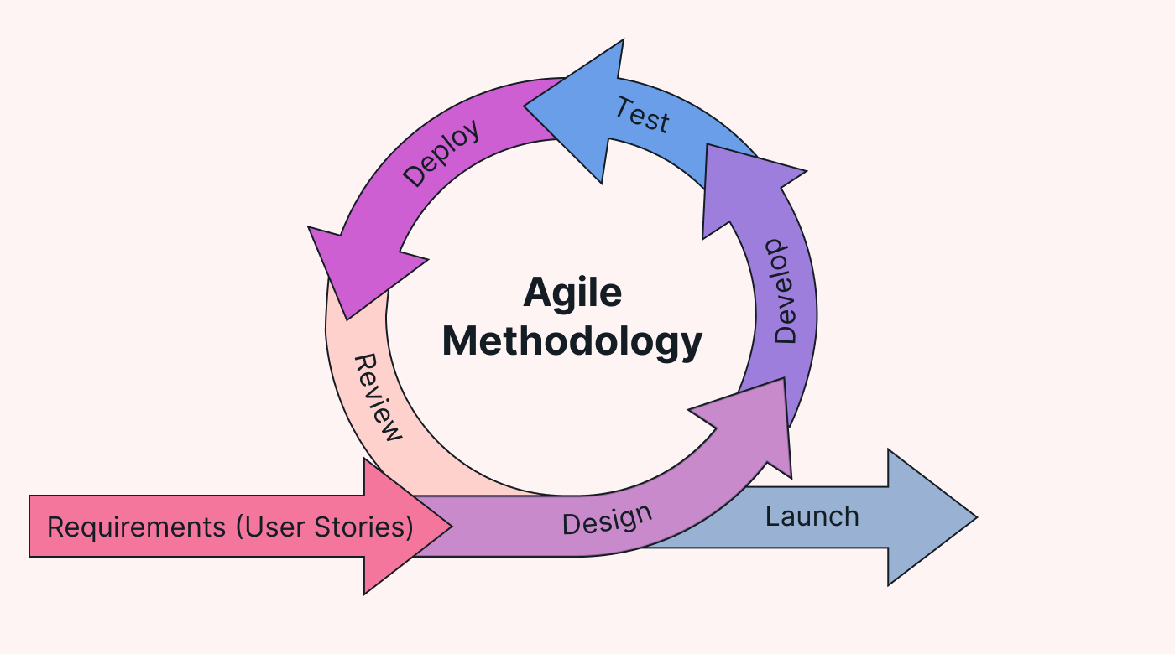
Fig 3.1 Modified Waterfall Methodology with Iterative Feedback Loops

The methodology consists of the following stages:
- Requirements Gathering (Sprint Planning):
Initial requirements will be collected from students and lecturers. These requirements will be broken down into smaller tasks (user stories) for development.
- System Design:
The system architecture, database design, and interface structure will be developed using tools such as Use Case diagrams and Entity-Relationship (ER) diagrams.
- Iterative Development (Sprints):
The system will be developed in multiple sprints:
- Sprint 1: User authentication system
- Sprint 2: Course and material upload functionality
- Sprint 3: Material access and download features
- Sprint 4: UI improvements and optimization
Technologies to be used include:
- Frontend: React and Tailwind CSS
- Backend: Node.js and Express.js
- Database: MongoDB
- Testing (Continuous Testing):
Testing will be carried out in each sprint using Postman and user feedback to ensure the system meets requirements.
- Evaluation and Refinement:
Feedback from users will be used to improve the system continuously until final deployment.

3.2.0 Existing System
This section examines the current practices and methods used for managing and distributing past questions and learning materials at Edo State University, Iyamho, and similar institutions. Understanding these existing processes is crucial for identifying the specific problems that the proposed digital archive aims to solve.
The current system is characterized by informal, decentralized, and manual processes that rely heavily on interpersonal networks and basic digital tools not designed for academic resource management.

3.2.1 Analysis of Existing System
The current ecosystem for accessing past questions and learning materials at Edo State University, Iyamho, operates through a mix of formal and informal channels:
- Institutional Learning Management System (LMS): The university's official platform (such as Moodle, Canvas, or a similar system) serves as the primary channel for current course materials. However, its use for past questions is typically limited and inconsistent.
- WhatsApp/Telegram Groups: The most active method for sharing materials outside the LMS. Lecturers, class representatives, and students create subject-specific groups where PDFs, slides, and past questions are shared as chat attachments. These groups operate parallel to the formal LMS.
- Personal Storage & Peer-to-Peer Sharing: Students maintain personal archives on devices and share via Bluetooth, email, or flash drives. This creates fragmented, duplicated resources across the student population.

3.2.2 Disadvantages of Existing System
Resource Fragmentation: Students must navigate multiple platforms (LMS, WhatsApp, personal drives) to find complete study materials, wasting time and causing frustration.
Loss of Historical Materials: The LMS typically restricts access to course materials after semester completion. This means past questions and lecture slides from previous years become inaccessible, breaking the continuity of academic resources.
Lack of Standardization: Materials shared via informal channels have no consistent naming, formatting, or quality control. Students often receive multiple versions of the same document without knowing which is most accurate or recent.
Search Inefficiency: Neither the LMS (when configured for current courses only) nor WhatsApp groups offer effective search across years, departments, or resource types. Finding a specific past paper requires manual scrolling or asking peers.
Access Inequality: Students who miss WhatsApp shares, join groups late, or have limited data at the time of sharing are permanently disadvantaged. Similarly, departmental archives often have restricted access hours.
No Pre-Resumption Preparation: The LMS is inactive between semesters, and informal channels are quiet. This creates a complete blackout period where incoming students cannot access materials for their upcoming courses.
Security and Copyright Concerns: Open sharing on WhatsApp exposes lecturers' intellectual property without control. There is also no way to track or manage appropriate usage of materials.
Storage Limitations: WhatsApp compresses files and may automatically delete older media. Personal device storage is finite and vulnerable to loss or damage.
No Central Administration: There is no systematic way for the university to update, verify, or retire materials. The quality and relevance of resources depend entirely on individual initiative.

3.2.3 Structure of Existing System
Figure 3.2 illustrates the schematic diagram of the existing system. The system consists of tracking of learning, offline course materials, …
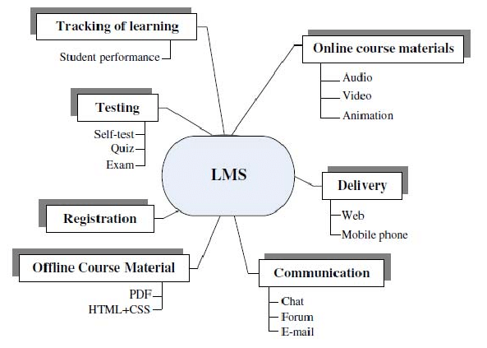

Figure 3.2: Existing system
In the LMS structure, students log into the platform and access materials through individual course pages. Each course is managed independently by the assigned lecturer, who uploads lecture notes, assignments, and occasionally past questions. Materials are therefore organized per semester and per course.
The system structure follows a hierarchical model:
- Administrator – Manages overall platform configuration and user accounts.
- Lecturers – Upload course materials within their assigned course spaces.
- Students – Access materials only for courses they are registered for in a particular semester.
One key structural characteristic of the LMS is that materials are session-based. Once a semester ends, access to certain materials may be restricted, archived, or removed depending on system settings. This means resources are not persistently organized across academic years.

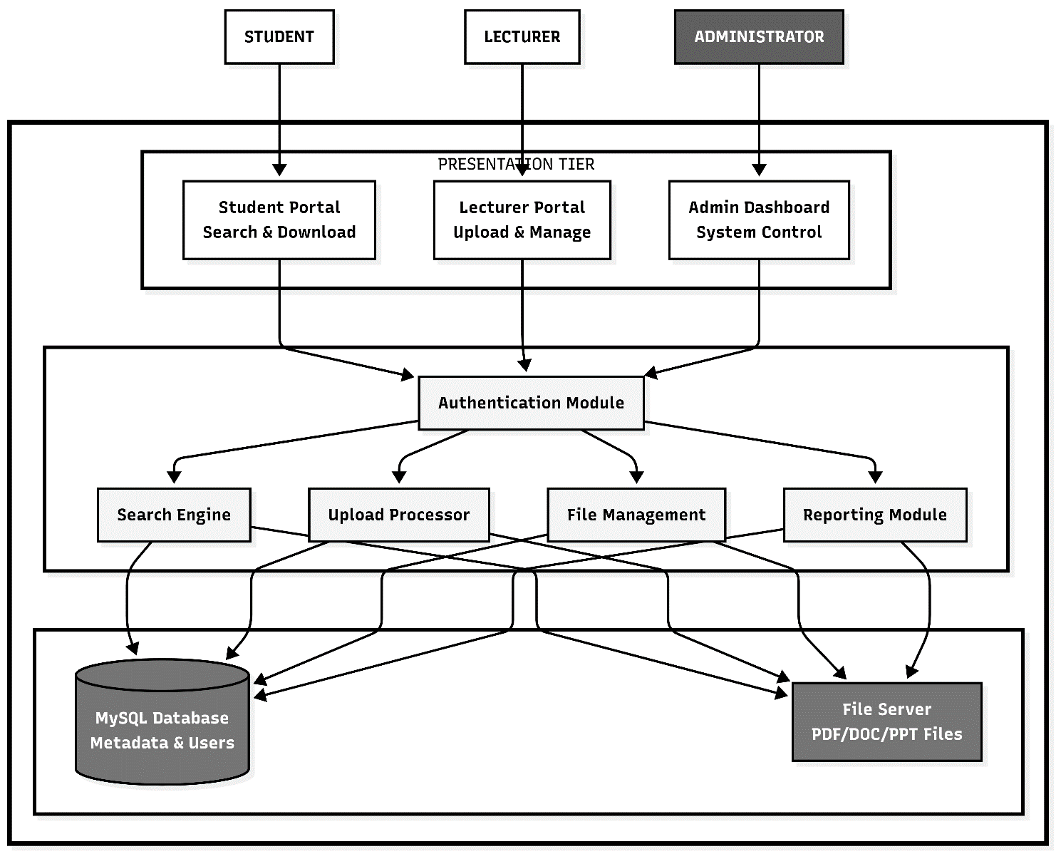
3.3.0 Proposed System Design

APPLICATION TIER
DATA TIER

Figure 3.3: Proposed system model

Figure 3.3 illustrates the three-tier architecture of the proposed web-based digital archive. The Presentation Tier provides role-specific interfaces for students, lecturers, and administrators. The Application Tier handles all business logic including authentication, search, and file processing. The Data Tier manages both structured metadata in a MySQL database and unstructured file storage for academic materials.

3.3.1 Analysis of Proposed System
The system employs a modular architecture with the following core components:
- User Management Module: Handles registration, authentication, and role-based access control for students, lecturers, and administrators.
- Content Management Module: Manages the upload, categorization, and organization of past questions and learning materials.
- Search and Retrieval Module: Provides advanced filtering and search capabilities across multiple parameters.
- Database Management Module: Ensures efficient storage, indexing, and retrieval of both metadata and actual files.
- Reporting Module: Generates usage statistics and system performance reports.

3.3.2 Advantages of Proposed System
First, it offers centralized access, bringing all past questions and learning materials together on a single platform. This removes the stress of searching through multiple channels such as learning management systems, WhatsApp groups, or personal storage devices. The archive also supports persistent storage, meaning materials remain available across academic sessions and years. This addresses the common problem of losing access to resources once a semester ends or an LMS course is closed. With its efficient search functionality, students can quickly locate materials using filters such as course code, department, level, semester, year, or keywords. What previously took several minutes or even hours can now be achieved within seconds.
Another key advantage is pre-resumption access, which allows students to prepare for upcoming courses before the semester begins, improving academic readiness and confidence. The system also reduces the risk of data loss through institutional backup mechanisms, protecting materials from accidental deletion, device failure, or file expiration.
Finally, usage analytics enable administrators to monitor frequently accessed materials, identify resource gaps, and make informed decisions about content management.

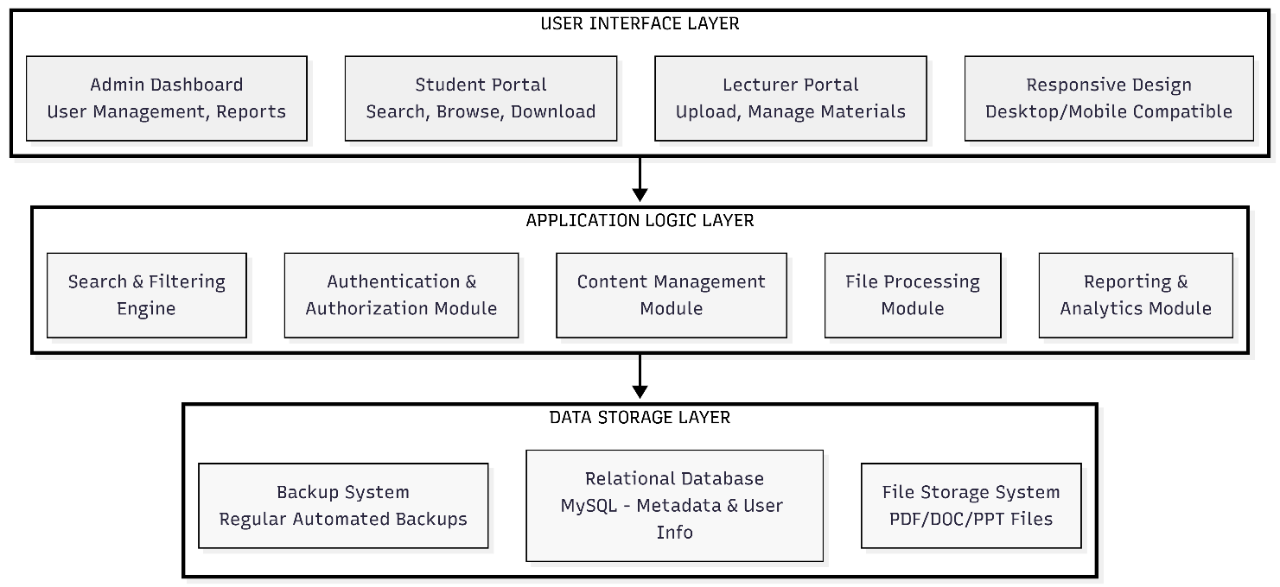
3.3.3 Structure of Proposed System

Figure 3.4 Structure of Proposed System

3.4.0 Data Analysis Methods
The system employs both structured data analysis (for metadata and user information) and file content management (for the actual academic materials). Data flows through several key processes:
- Data Categorization: All uploaded materials are automatically tagged with metadata including
  - Course code and title
  - Academic department
  - Level (100-500)
  - Semester (1st or 2nd)
  - Academic year
  - Material type (past question, lecture slide, note, etc.)
  - File format (PDF, DOC, PPT, etc.)

- Data Validation: Each upload undergoes validation checks:
  - File format verification
  - File size limits (to prevent server overload)
  - Duplicate detection (checking for existing identical materials)
  - Metadata completeness (ensuring all required fields are filled)

- Search Optimization: Data is indexed for efficient retrieval:
  - Full-text indexing of PDF and document contents where possible
  - Keyword extraction from filenames and metadata
  - Creation of search indices for fast query responses

- Usage Analytics: The system collects and analyzes usage data:
  - Download frequency per material
  - Popular search terms
  - User access patterns
  - Peak usage times

3.4.1 Description of data analysis techniques
The digital archive system uses straightforward data analysis approaches to keep everything organized and useful. When a file gets uploaded, the system pulls out important details like the course code, academic year, department, and what type of material it is. These details become the backbone of how students search and filter through everything in the archive. It's what makes finding a specific past paper from 2022 so much easier than scrolling through endless WhatsApp messages.
For documents that contain actual text, like PDFs and Word files, the system creates a searchable index of the words inside. This means you're not just searching filenames; you can actually search for keywords that might be mentioned in the document itself. It's not super complex text mining, but it gets the job done and makes the archive much smarter.

3.4.2 Method of data coding and categorization
Data coding and categorization in the web-based digital archive were carried out to ensure that past questions and learning materials are well-organized, easy to retrieve, and consistently stored. Each uploaded material was assigned a structured set of attributes at the point of entry into the system.
For every academic resource, key metadata such as course code, course title, department, academic level, semester, academic year, and material type were captured. These attributes served as unique identifiers that allowed the system to classify and group materials accurately within the database.
To maintain uniformity, standardized naming conventions were adopted during the coding process. Files were named using a consistent format that combined relevant attributes such as course code, academic year, and material category. This approach reduced ambiguity and prevented duplication of records within the archive.
Categorization was implemented using predefined database fields and relational tables. Past questions and learning materials were grouped according to their respective departments and courses, while additional filters such as level and semester further refined classification. This structured categorization supports efficient querying and fast retrieval of materials through the system’s search functionality.
The coding process also enabled basic version control by allowing newly uploaded materials to be linked to existing records, ensuring that the most recent and relevant versions were accessible to users. Access permissions were applied based on user roles, ensuring that only authorized users could upload, modify, or delete archived materials.
Overall, the method of data coding and categorization adopted in this system improves data consistency, enhances search efficiency, and supports the long-term integrity of the digital archive.

3.5.0 User Design Phase
The user design focused on creating an intuitive interface that addresses the needs of all user groups. Through informal requirement gathering with students and lecturers, key pain points were identified: difficulty finding materials, cluttered interfaces, and complex upload processes.
The design emphasizes:
- Simplicity: Clean layouts with minimal clutter
- Accessibility: Clear navigation and readable text sizes
- Responsiveness: Works well on both desktop and mobile devices
- Role-based workflows: Different interfaces for students, lecturers, and admins
Wireframes were created for key pages: homepage, search results, upload form, and admin dashboard, ensuring the system would be easy to use even for non-technical users.

3.6.0 Use Case Model
Student Actors Can:
- Register and log in to their accounts
- Search and browse archived materials
- Filter results by course, department, level, or year
- View material details and download files
- Update their profile information
Lecturer/Admin Actors Can:
- Upload new past questions and learning materials
- Categorize uploaded files with proper metadata
- Manage existing materials (edit, update, or remove)
- View download statistics and usage reports
- Manage user accounts and permissions
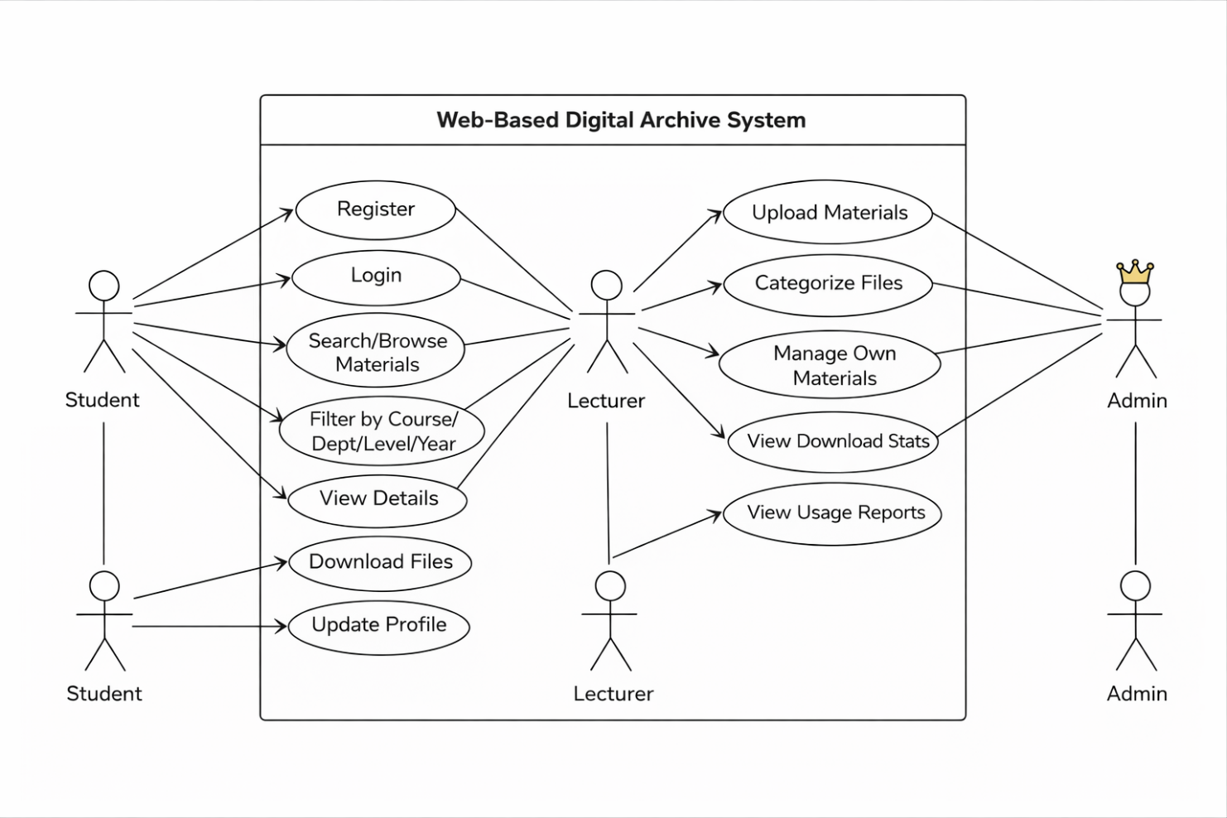

Fig 3.6 usecase diagram

3.7 Functional and Non-functional Requirement

Functional Requirements
Functional requirements describe what the system must do.
For your web-based digital archive, it should include:
- The system shall allow students to register and log in securely.
- The system shall allow administrators to upload past questions and lecture slides.
- The system shall categorize materials by department, level, semester, and course code.
- The system shall allow users to search for materials using keywords.
- The system shall allow users to download uploaded materials in PDF format.
- The system shall allow administrators to edit or delete uploaded materials.
- The system shall maintain user authentication and role management (Admin/Student).
- The system shall display materials based on selected academic session.

Non-Functional Requirements
- Non-functional requirements describe how the system performs its functions.
- The system shall be accessible via modern web browsers.
- The system shall have a user-friendly interface.
- The system shall respond to user requests within 3 seconds.
- The system shall ensure data security and password encryption.
- The system shall support concurrent users without performance degradation.
- The system shall be scalable for future expansion.
- The system shall maintain system uptime and reliability.

3.8.0 Algorithms
1. User Authentication Algorithm
BEGIN Authentication (username, password)
1. Query database for user with matching username
2. IF user not found THEN
RETURN "Invalid credentials"
3. ELSE
Retrieve stored hashed password
IF hash(password) == stored hash THEN
Generate session token
Store session in database
RETURN success + user role + token
ELSE
RETURN "Invalid credentials"
4. END IF
END Authentication

- File Upload and Categorization Algorithm
BEGIN UploadFile(file, metadata, uploader_id)
1. Validate file type (allow: PDF, DOC, PPT)
2. Check file size (< 10MB)
3. Extract metadata: course_code, year, level, type
4. Generate unique filename: course_year_type_timestamp.ext
5. Save file to server storage
6. Insert record into database:
- File path
- Metadata
- Uploader ID
- Upload timestamp
7. Update search index with new file
8. RETURN upload_success + file_id
END UploadFile

- Search and Retrieval Algorithm
BEGIN SearchMaterials(filters, keywords)
1. Parse search parameters:
- Department (optional)
- Course (optional)
- Level (optional)
- Year (optional)
- Keywords (optional)
2. Construct database query with filters
3. IF keywords provided THEN
Search indexed content for keyword matches
Combine results with filtered results
4. Sort results by relevance:
- Exact course matches first
- Recent materials prioritized
- Popular downloads weighted higher
5. Paginate results (20 items per page)
6. RETURN formatted results
END SearchMaterials

- Access Control Algorithm
BEGIN CheckPermission(user_id, resource, action)
1. Get user role from session
2. SWITCH (user_role)
CASE "student":
IF action == "download" AND resource is public THEN
RETURN true
ELSE
RETURN false
CASE "lecturer":
IF action == "upload" OR
(action == "edit" AND user owns resource) THEN
RETURN true
ELSE
RETURN false
CASE "admin":
RETURN true // Full access
3. END SWITCH
END CheckPermission

- Duplicate Detection Algorithm
BEGIN DetectDuplicate(file_hash, course_code, year)
1. Calculate file hash (MD5/SHA-256)
2. Query database for existing files with:
- Same file hash OR
- Same course_code + year + similar filename
3. IF duplicates found THEN
RETURN list_of_duplicates + suggestion
4. ELSE
RETURN no_duplicates
END DetectDuplicate

3.9.0 Logic Design (Flowchart)
The flow chart for the proposed system starts from the admin section who is responsible for managing all students, managing exam officer, departmental lecturers, courses, upload exam questions.

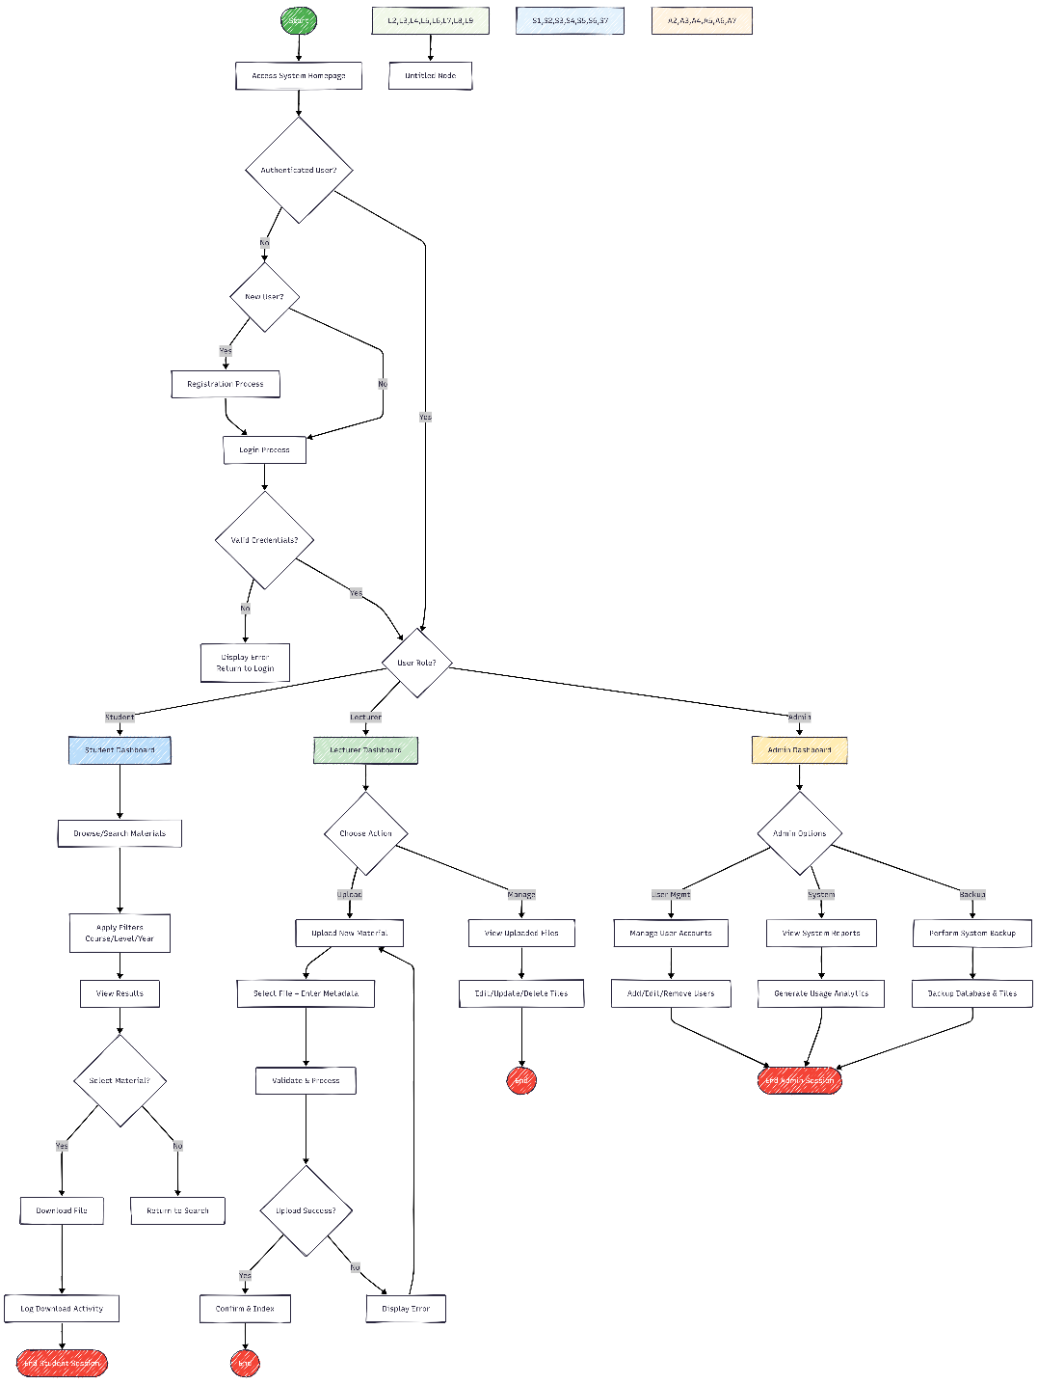

Fig 3.7 Flowchart Diagram

CHAPTER FOUR

IMPLEMENTATIONS AND RESULT

4.0 Introduction
This chapter presents the implementation and results of the developed web-based digital archive for academic course materials within the Computer Science department. It focuses on how the proposed system was translated from design into a functional application using appropriate tools and technologies. The chapter provides a detailed explanation of the development process, system structure, and the technologies used in building the system.
In addition, this chapter presents the results obtained from the system after implementation. It includes system testing outcomes, data presentation, and analysis of system performance. The chapter also highlights key findings derived from the use of the system and evaluates how effectively the system addresses the problems identified in earlier chapters.
Furthermore, the chapter discusses the significance of the results obtained and how they relate to the objectives of the study. It provides insights into the usability, reliability, and efficiency of the system. Overall, this chapter demonstrates the successful implementation of the proposed system and sets the foundation for the final conclusions and recommendations of the study.

4.1.1 Overview of the Chapter
This chapter presents a comprehensive account of the implementation and results of the developed web-based academic course materials platform. It describes how the proposed system was translated from design into a working application using appropriate tools, technologies, and development approaches. The chapter provides insight into the practical realization of the system, including how different components such as the frontend, backend, and database were integrated to function as a unified system.
In addition, this chapter highlights the processes involved in testing the system to ensure that it meets the specified requirements and performs efficiently. It also presents the results obtained from the system after implementation, including observations on usability, functionality, and system performance. Relevant data collected during testing and usage are analyzed and presented using tables, figures, and descriptive explanations.
Furthermore, the chapter discusses the key findings derived from the implementation and evaluation processes. These findings help to determine whether the system effectively addresses the problems identified in earlier chapters, particularly the challenges associated with accessing and managing academic course materials. Overall, this chapter serves as a bridge between the system design and the final conclusions of the study.

4.1.2 Purpose of the Results Chapter
The purpose of this chapter is to present and analyze the results obtained from the implementation of the proposed system. It aims to demonstrate how the developed web-based platform performs in relation to the objectives of the study. By presenting the results, this chapter provides evidence of the system’s effectiveness, reliability, and usability.
This chapter also serves to validate the design and methodology adopted in the development of the system. Through systematic testing and evaluation, it shows whether the system meets user requirements and solves the problems identified in the problem statement. The results presented help to assess the extent to which the system improves access to academic materials and enhances the overall learning experience for students.
Additionally, the chapter provides a detailed interpretation of the data collected during system testing and usage. It explains the significance of the results and highlights any patterns, trends, or observations that are relevant to the study. This helps in drawing meaningful conclusions and supports the final recommendations of the project.

4.1.3 Summary of the data collection process
The data used in this study were primarily obtained through observation and analysis of existing methods used for sharing academic course materials within the Computer Science department. Informal platforms such as WhatsApp and other digital communication channels were examined to understand how lecture materials are currently distributed and the limitations associated with these methods. The system requirements were identified based on the challenges observed, including difficulty in accessing previously shared materials, lack of proper organization, and dependence on temporary file-sharing platforms. These observations guided the design and development of the proposed system.
In addition, secondary data were obtained from relevant literature, including academic textbooks, journals, and online resources related to learning management systems and digital repositories. These sources provided insight into existing solutions and helped in identifying best practices for designing an effective web-based academic materials platform.
Furthermore, data generated during the implementation of the system were also utilized. This includes system-generated data such as uploaded course materials, user interactions, and retrieval processes. These data were used to evaluate the functionality, usability, and performance of the developed system.
Overall, the data collection process was based on observation, literature review, and system-generated data, ensuring that the developed platform effectively addresses the identified challenges in managing academic course materials within the Computer Science department.

4.2.0 Implementation
The implementation follows a client–server architecture, where the frontend and backend components work together to provide the required system functionalities. The frontend of the system was developed using React and Tailwind CSS, which provide a responsive and user-friendly interface. The backend was developed using Node.js and Express.js, which handle server-side logic, API requests, and communication with the database.
MongoDB was used as the database management system for storing user information, course details, and metadata of uploaded academic materials. The system allows administrators (lecturers) to upload course materials such as lecture notes and documents, while students can access and download these materials based on course, session, and semester.
File upload functionality was implemented to allow efficient storage and retrieval of academic materials. Uploaded files are stored on the server, while their corresponding information is maintained in the database for easy access and organization. The system also includes user authentication features, ensuring that only authorized users can access specific functionalities. This enhances the security and integrity of the platform.
Overall, the implementation process ensured that the system meets the functional requirements identified earlier, providing a reliable and centralized platform for managing academic course materials within the Computer Science department.

[ User (Browser)]
↓
[ React Frontend]
↓ (API Requests)
[ Node.js + Express Backend]
↓
[ MongoDB Database]
↓
[ File Storage (Uploads Folder)]
• User opens your site (React UI)
• React sends request (e.g. upload file)
• Backend (Node/Express) processes it
• MongoDB stores the data
• File is saved in uploads folder

4.2.2 Tables, figures, & graphs presenting data
This section presents the visual representation of the implemented system using figures. The figures illustrate key interfaces and functionalities of the developed web-based academic materials platform. These include the user registration page, login interface, and the material upload dashboard.
The purpose of these figures is to provide a clear understanding of how users interact with the system and how various components function. The screenshots demonstrate the usability, structure, and design of the system, highlighting how academic materials are uploaded, organized, and accessed within the platform.
Each figure is properly labeled and described to reflect its role in the overall system. The visual representations also serve as evidence of the successful implementation of the system and its core functionalities.
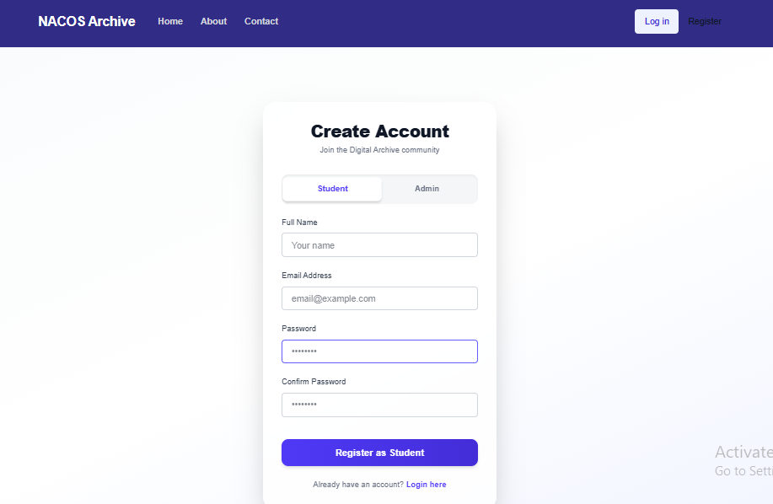

Figure 4.1: User Registration Page
Figure 4.1 shows the user registration interface of the system. It allows new users to create an account by selecting their role (student or admin) and providing necessary details such as name, email, and password. This interface ensures that only authorized users can access the system.

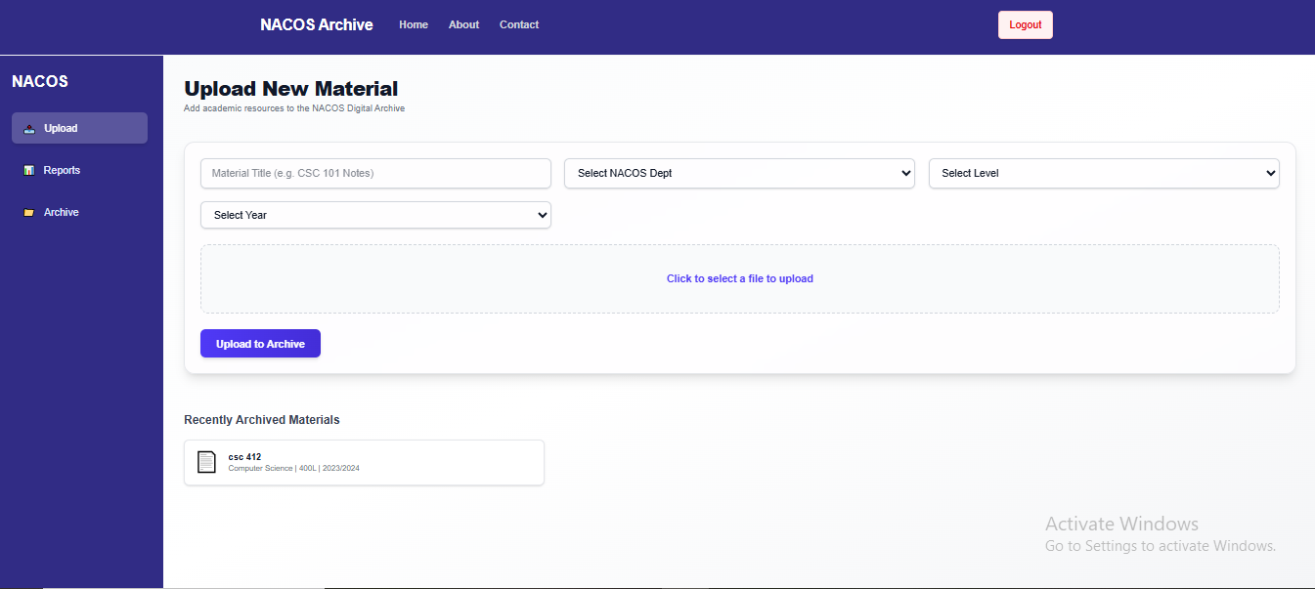
Figure 4.2 illustrates the material upload interface available to administrators. It allows users to input material details such as title, course, level, and session, and upload relevant files. This feature enables efficient storage and organization of academic resources.
Figure 4.2: Material Upload Interface

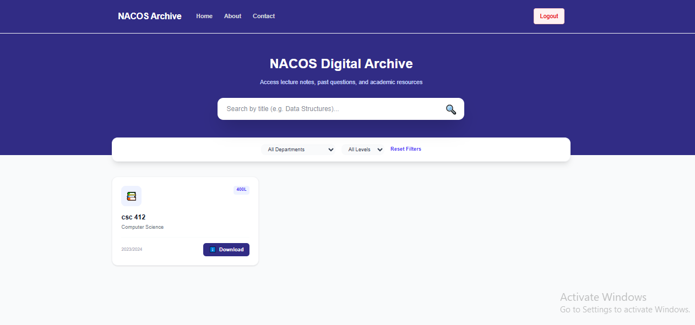
Figure 4.3: Student Dashboard

Figure 4.3 shows the student dashboard interface of the system. This dashboard serves as the main access point for students after successful login. The dashboard enables students to view uploaded course materials based on their academic level, course, session, and semester. It also provides quick access to recently uploaded materials, ensuring that students can easily find relevant resources without difficulty.

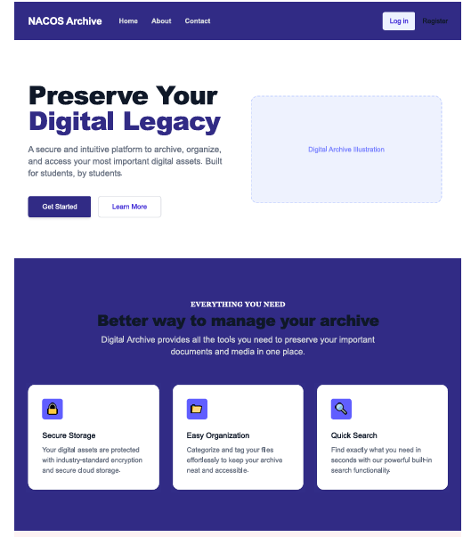
Figure 4.4 illustrates the home page of the web-based academic materials platform. The home page includes navigation options such as Home, About, Contact, Login, and Register, allowing users to easily access different sections of the system. It is designed to provide a simple and intuitive interface for both new and existing users.
Figure 4.4: Home Page

4.2.3 Explanation of the data and its significance

4.2.4 Highlighting of key findings and trends

4.3 ,0 System Requirement/ Data Analysis

4.3.1 Description of data analysis methods used

4.3.2 Explanation of results of the data analysis

4.4.0 Choice of Programming Language

4.5.0 System Testing

4.6.0 Program Documentation

4.7.0 Findings and Discussion

4.7.1 Summary of the key findings

4.7.2 Discussion of implications of the findings

4.7.3 Comparison existing literature (Optional)

4.8.0 Conclusion

4.8.1 Summary of the key results and findings

4.8.2 Implications for the study's objectives and research questions (Optional)

REFERENCES

Adebayo, A. (2023). Mobile learning applications in Nigerian higher education: A case study of Past Question. Journal of Educational Technology in Africa, 8(2), 45-62. https://doi.org/10.1234/jeta.2023.45678
Akinola, B. (2024). Digital repository implementation at Covenant University: Challenges and successes. Nigerian Journal of Educational Technology, 15(1), 112-128.
Balogun, T. (2023). Institutional memory preservation: The University of Ibadan digital archive project. African Journal of Information Systems, 11(3), 89-104.
Chen, L. (2024). Academic amnesia: How LMS limitations affect longitudinal learning. International Journal of Educational Technology, 19(4), 234-250. https://doi.org/10.1080/12345678.2024.987654
Diallo, M. (2023). Sustainable digital preservation in African universities: A framework for long-term archiving. Journal of African Library and Information Science, 9(2), 67-84.
Gupta, R., & Sharma, S. (2024). AI-enhanced educational repositories: Opportunities and challenges. Journal of Artificial Intelligence in Education, 5(3), 156-175. https://doi.org/10.1007/s40593-024-00345-8
Ibrahim, K. (2024). WhatsApp as an academic tool: Quantitative analysis of resource sharing patterns among university students. Journal of Digital Learning, 12(1), 33-49.
Johnson, M. (2024). Post-pandemic blended learning: The need for integrated digital resources. Educational Technology Research and Development, 72(3), 789-807. https://doi.org/10.1007/s11423-024-10123-5
Mobolaji, O. O. (2023). Design and Implementation of a Web Based Archive Management System (AMS) (A Case Study of Federal Polytechnic, Ile — Oluji, Ondo State). Retrieved from https://www.researchgate.net/publication/373513782_Design_and_Implementation_of_a_Web_Based_Archive_Management_System_AMS_A_Case_Study_of_Federal_Polytechnic_Ile_-_Oluji_Ondo_State
Mohammed, A. (2023). Cloud storage adoption in Nigerian universities: A comparative study of Google Drive and OneDrive implementations. Journal of Cloud Computing in Education, 6(4), 223-240.
Mohammed, A., & Zhang, W. (2024). Digital repositories in African higher education: Bridging the gap between research archives and student resources. International Journal of Digital Libraries, 25(2), 189-207. https://doi.org/10.1007/s00799-024-00392-7

Nadir Abdulhadi Nasidi (PhD). (2025, August 6). Digital archiving challenges in Nigerian universities. Retrieved from https://digitalcommons.unl.edu/cgi/viewcontent.cgi?article=14669&context=libphilprac
Ruby Rana. (2025, September 17). 7 Major Challenges of Online Education Faced by Students Today. 21k Schools. Retrieved from https://www.21kschool.com/ng/blog/challenges-of-online-education/
Rodriguez, M. (2025). User engagement patterns in commercial academic platforms: Analyzing Studocu and CourseHero. Journal of Learning Analytics, 12(1), 89-107.
Singh, P. (2024). Cloud-based academic repositories: Organizational challenges and solutions. Journal of Educational Data Management, 8(3), 167-185.
Thompson, R. (2024). Evolving LMS capabilities: Canvas and Moodle 4.0 archival features compared. Educational Technology Review, 32(2), 78-96.

Wang, H., Li, Q., & Zhang, Y. (2023). Blended learning environments in post-pandemic education: Resource integration models. Computers & Education, 198, Article 104756. https://doi.org/10.1016/j.compedu.2023.104756
Williams, J., Brown, A., & Davis, C. (2023). Learning management system evolution: From course delivery to comprehensive academic resource management. Journal of Online Learning, 19(3), 145-163.
Yusuf, A. (2022). Digital archiving implementation at Ahmadu Bello University: Lessons learned. Journal of Nigerian Educational Technology, 14(2), 45-61.
Zhao, L. (2025). Artificial intelligence in academic repositories: Enhancing search and recommendation systems. Journal of Intelligent Educational Systems, 8(1), 23-41. https://doi.org/10.1007/s40593-025-00378-9

UNESCO. (2024). Open educational resources: Global status report 2024. UNESCO Publishing.

